**Year 1 Number and Place Value**

Count to and across 100, forwards and backwards, beginning with 0 or 1, or from any given number

* count forwards from 80 to 110
* count backwards from 105

Count, read and write numbers to 100 in numerals; count in multiples of twos, fives and tens

* Find p.39 in a book
* Make a label to show how many things were in your collection
* Count groups of 10 each of 2p, 5p and 10p coins

Given a number, identify one more and one less

*There are twenty nine beads in this pot. I am putting one more bead in the pot. How many are in there now? How did you know? How can you check?*

*This time there are forty beads in the pot. I take out one bead. How many beads are left in the pot? How did you know? How can you check?*

*Start with a different number of beads in the pot. Ask your partner to put another bead in or take one out and then say how many there are in the pot. How will you know if your partner is right?*

Identify and represent numbers using objects and pictorial representations including the number line, and use the language of: equal to, more than, less than (fewer), most, least

*I'm giving each of you a strip of card with some numbers on [five numbers at random from 0 to 30].*

*Point to the number which is worth most. Now point to the number which is worth least.*

*Make these numbers using tens and ones apparatus and put them in order.*

*Why have you put this number there?*

Read and write numbers from 1 to 20 in numerals and words

Make some labels for collections using numbers and words.

**Year 1 Addition and Subtraction**

Read, write and interpret mathematical statements involving addition (+), subtraction (–) and equals (=) signs

* Use the vocabulary add, subtract, minus, equals, is the same value as, total, more than, fewer/less than.
* Explain that things on both sides of the equals sign have the same value
* Know that the ‘total’ can be presented on either side of the equals sign
* Complete ‘empty box’ number sentences

Represent and use number bonds and related subtraction facts within 20

* I’m thinking of a number. I’ve subtracted 6 and the answer is 8. What number was I thinking of? Explain how you know.
* I’m thinking of a number. I’ve added 7 and the answer is 18. What number was I thinking of? Explain how you know.
* I know that 6 and 4 is 10. How can I find 7 + 4? How could you work it out?

Add and subtract one-digit and two-digit numbers to 20, including zero

* What is 37 subtract 10? How did you work that out? How could you show that using cubes/a number line/a 100-square? What would 37 subtract 20 be?
* Make up some difference questions with the answer 5. Can you show how to solve them using counters? Can you show how to find the answer on a number line?

Solve one-step problems that involve addition and subtraction, using concrete objects and pictorial representations, and missing number problems,

such as 7 = ? – 9.

* Make up some additions with the answer 15. Try to put them in different ways, like this: 10 + 5 = 15. The total of 10 and 5 is 15. 10 and 5 more makes 15.
* How many ways can you show me that 9 subtract 3 is 6?
* Make up some subtractions with the answer 5. Try to put them in different ways, like this: 11 – 6 = 5. The difference between 6 and 11 is 5.

**Year 1 Multiplication and Division**

Solve one-step problems involving multiplication and division, by calculating the answer using concrete objects, pictorial representations and arrays with the support of a teacher

Children should be able to:

* Use practical apparatus, arrays and images to help solve multiplication and division problems such as:

Ben had 5 football stickers. His friend Tom gave him 5 more, how many does he have altogether?

Share 12 sweets between two children. How many do they each have?

* Find half of and double a number or quantity:

16 children went to the park at the weekend. Half that number went swimming. How many children went swimming?

I think of a number and halve it. I end up with 9, what was my original number?



**Year 1 Fractions**

Recognise, find and name a half as one of two equal parts of an object, shape or quantity

Here is a set of 12 pencils

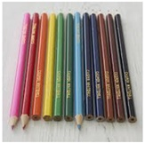

How many is half the set?

Shade one quarter of each shape 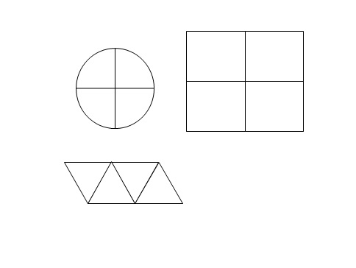

Recognise, find and name a quarter as one of four equal parts of an object, shape or quantity

Four Children share 12 strawberies into equal parts.

How many strawberries will each child have?

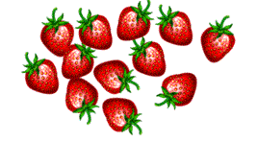

**Year 1 Properties of Shapes**

Recognise and name common 2-D and 3-D shapes, including [for example] rectangles (including squares), circles, triangles, cuboids (including cubes), pyramids and spheres.

**Give each child this shape**

Child A

shape

Child B

Child C

shape

Child D

shape

Look at the Shape I have given you. Tell me one thing about the shape.

**Hand each child this shape.**

Child A:cylinder

Child B:triangular prism

Child C:cone

Child D:cube

Look at the shape I have given you. Tell me one thing about the shape.

(Give each child two different shapes.)

Tell me something that is the same about the two shapes.

Now tell me something that is different abiout the two shapes.

One shape has 2 long sides and 2 short sides.

Tick (✔) it.

**Fred draws round the bottom of a cone.**

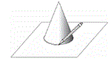

Tick (✔) the shape that Fred draws.

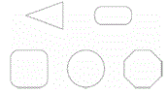

**Year 1 Position and Direction**

Pupils describe position, direction and movement, including whole, half, quarter and three-quarter turns.

Look at the map. Go to start.

Follow this route from there.

Go to the fourth house on the right.

Draw a ring around it.

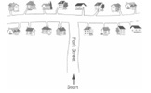

Look at this map

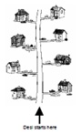

Desi's house is the 2nd on the left. Tick ( ✔) it.

**Year 1 Measurement**

Compare, describe and solve practical problems for:

* lengths and heights (e.g. long/short, longer/shorter, tall/short, double/half)
* mass or weight (e.g. heavy/light, heavier than, lighter than)
* capacity/volume (full/empty, more than, less than, quarter)
* time (quicker, slower, earlier, later)
* Use their experience of standard units to make realistic estimates, answering questions such as:
  + Is the table taller or shorter than a metre?
  + Is this doll taller or shorter than one of the class rulers?
  + Does this bottle hold more or less than the litre jug?
  + Which of these things do you think will weigh less than a kilogram?

Measure and begin to record the following:

* lengths and heights
* mass/weight
* capacity and volume
* time (hours, minutes, seconds)
* Use standard units to measure and compare objects. For example, they place metre sticks end-to-end to find out how much wider the hall is than the classroom. They use a litre jug to measure how much more the washing-up bowl holds than the cola bottle.

Recognise and know the value of different denominations of coins and notes

* Distinguish coins by sorting them and start to understand their value. They begin to recognise that some coins have a greater value than others, and will buy more: for example, 2p is worth more than 1p; 5p is worth more than 2p; £2 is worth more than £1. They play money games and collect 1p or 2p coins to the value of 10p and begin to count up ‘how much this is altogether’. They extend their activities in the classroom shop, paying for items that cost 1p, 3p, 5p, 7p or 9p using only 2p coins, and receiving the appropriate amount of change in 1p coins.

They use coins to help them to respond to questions such as:

* + Michael had £5. He spent £3. How much did he have left?
  + Rosie had a 10p coin. She spent 3p. How much change did she get?
  + How much altogether is 1p and 2p and 5p?
  + Sunita spent 5p and 6p on toffees. What did she pay altogether?
  + Chews cost 2p each. How much do three chews cost?
  + An apple costs 12p. Which two coins would pay for it? What combinations of 3 coins would pay for it?

Sequence events in chronological order using language such as: before and after, next, first, today, yesterday, tomorrow, morning, afternoon and evening

* Continue to develop the concept of time in terms of time passing and sequencing events in familiar story or day-to-day routines.
* They use terms such as morning, afternoon and evening, yesterday and tomorrow.
* They learn to order the days of the week and learn that weekend days are Saturday and Sunday.
* They listen to stories and rhymes about time, such as The Very Hungry Caterpillar or The Bad-Tempered Ladybird by Eric Carle, Monster Monday by Susanna Gretz or Hard Boiled Legs by Michael Rosen and Quentin Blake.

Recognise and use language relating to dates, including days of the week, weeks, months and years

* order the months of the year and make a 12-page classroom calendar with pictures of each month, writing significant events underneath, such as Divali, Pancake Day or Midsummer’s Day, or the dates of their birthdays.

Tell the time to the hour and half past the hour and draw the hands on a clock face to show these times

* Read time to the hour and half hour on a clock with hands and recognise half past the hour in day-to-day routines. They use time lines or clocks to help them to respond to questions such as:
* It’s half past seven. What time will it be in four hours’ time? What time was it two hours ago?
* John went to the park at 9 o’clock. He left at half past eleven. How long was he at the park?